Partition a hard drive in Windows : How it works

Hard disks are usually integrated into the hardware setup as a **single drive**. However, if you want to separate the Windows installation from your games, programs, or sensitive documents, it makes sense to **partition the hard drive**. Continue reading to find out how to do this in Windows 11.

Bottom of Form

Step by step: How to partition hard disks in Windows 11

Step 1: Open Disk Management

No additional software is required to partition a hard drive in Windows 11. The operating system has its own tool exactly for this purpose, known as the **Disk Management**. There are two options to start this tool:

1. Use the key combination **[Windows] + [R]** to open the “Run” dialog box and choose the command “**diskmgmt.msc**”.
2. [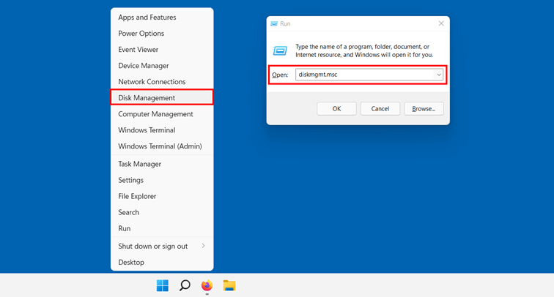](https://www.ionos.com/digitalguide/fileadmin/DigitalGuide/Screenshots_2022/win11_festplatte01_en.png)Right-click on the **Start menu icon** in the taskbar and select “**Disk Management**”.

Windows 11: Select Disk Management

Step 2: Selection of the data carrier

The Disk Management lists all the hard disks and removable media which are connected to your device. Firstly, **select the hard disk** you want to format. In Windows, you will see two overviews – **sorted by volume and sorted by disk**. Clicking on one of the volumes in the upper window will automatically show the corresponding disk overview below.

[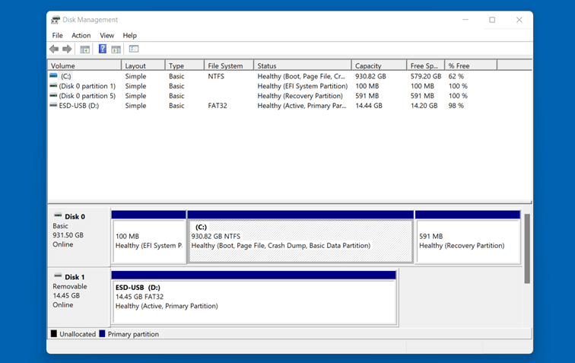](https://www.ionos.com/digitalguide/fileadmin/DigitalGuide/Screenshots_2022/win11_festplatte02_en.png)Windows 11: Disk Management

Step 3: Shrink volume

In order to partition a hard disk in Windows 11, you must first reduce the size of the disk. To do this, right-click the disk you have chosen – in this case, the Windows disk will be the main partition – and then click “**Shrink Volume**”.

[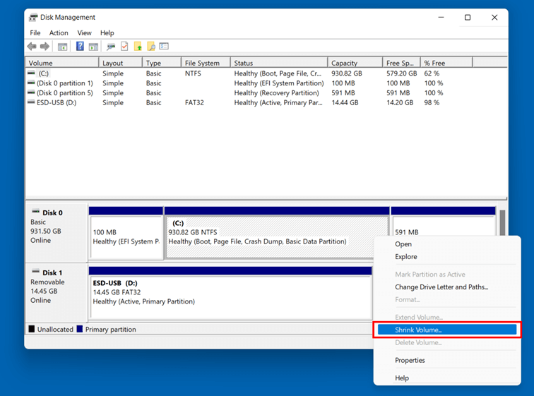](https://www.ionos.com/digitalguide/fileadmin/DigitalGuide/Screenshots_2022/win11_festplatte03_en.png)

Shrink Volume in Windows 11

In the following dialog box, you can specify how much **space** the new partition should have. By default, Windows 11 will offer to shrink the entire available memory on the hard disk. If you want to assign a smaller amount of memory to the partition, simply adjust the value beside “**Enter the amount of space to shrink in MB**”. You can specify the value in [megabyte](https://www.ionos.com/digitalguide/websites/web-development/what-is-a-megabyte/). For example, to reduce the current volume of the **partition by 200 gigabytes**, specify the value “**204800**”.

Finally, click “**Shrink**”.

[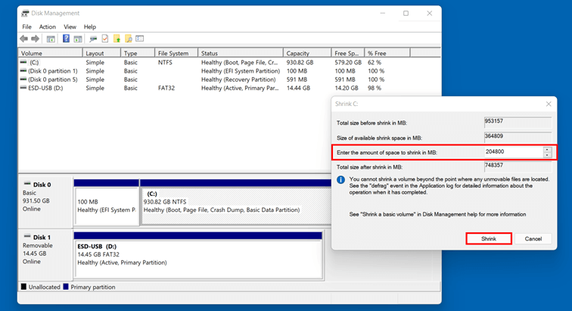](https://www.ionos.com/digitalguide/fileadmin/DigitalGuide/Screenshots_2022/win11_festplatte04_en.png)Shrink drive in Windows 11

Step 4: Create partition

In the overview, you will see an **unallocated storage quota** whichyou can use for the new partition. Right-click the area and then select the “**New Simple Volume**” in the menu.

[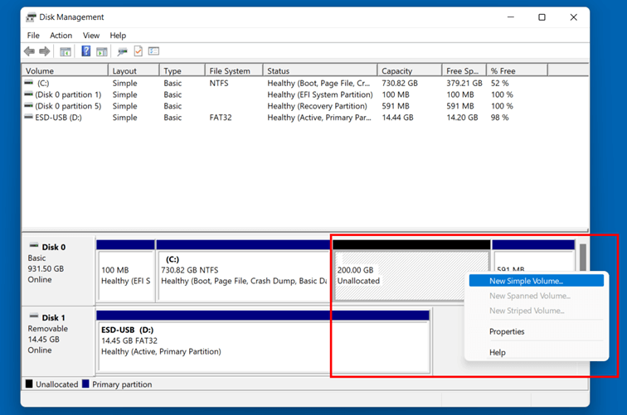](https://www.ionos.com/digitalguide/fileadmin/DigitalGuide/Screenshots_2022/win11_festplatte05_en.png)Windows 11 Disk Management: Unallocated storage

The New Simple Volume Wizard will begin. Firstly, click “**Next**” and then specify the **volume of the new partition**. Keep the maximum value if you want to work with the entire amount of memory previously which was previously shrunk. Then click “**Next**” again.

[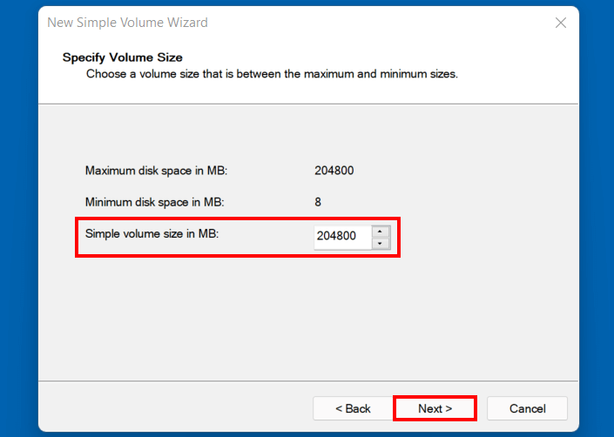](https://www.ionos.com/digitalguide/fileadmin/DigitalGuide/Screenshots_2022/win11_festplatte06_en.png)Windows 11: Set volume size

The next step is to assign a **drive letter**. Windows 11 will automatically default to the next letter of the alphabet – but you can also select any other available letter by opening the **drop-down menu**.

[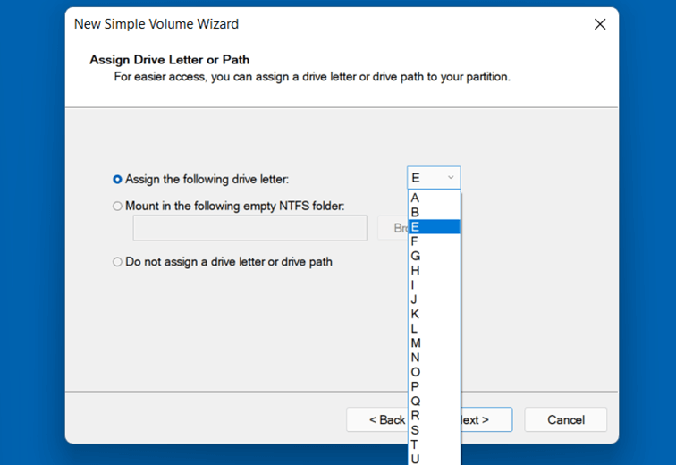](https://www.ionos.com/digitalguide/fileadmin/DigitalGuide/Screenshots_2022/win11_festplatte07_en.png)Assign drive letters in Windows 11

In the last step of the disk partitioning, you must set the formatting options and the name of the new partition. For this, choose the option “**Format this volume with the following settings**” and select:

* the **File system**– the classic choice for Windows systems is: [NTFS](https://www.ionos.com/digitalguide/server/know-how/ntfs/)
* the **size of the Allocation unit size**, also called cluster size (recommended setting: “Default”)
* the **Volume label** (name of the partition)

Check the “**Perform a quick format**” box and finish partitioning the hard disk by clicking “**Next**” and “**Finish**”.

[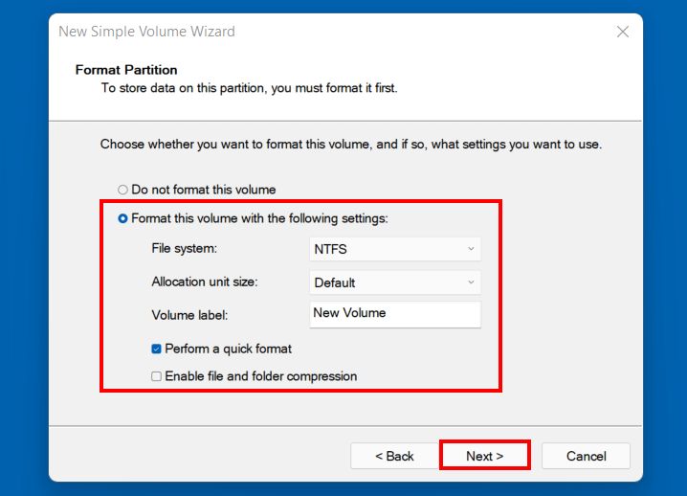](https://www.ionos.com/digitalguide/fileadmin/DigitalGuide/Screenshots_2022/win11_festplatte08_en.png)Partition a hard disk in Windows 11

The new partition of the hard disk will be displayed in Disk Management if the formatting and partitioning were successful.

[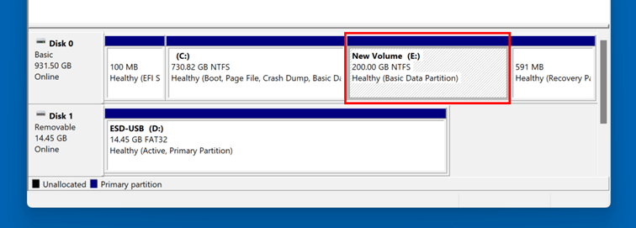](https://www.ionos.com/digitalguide/fileadmin/DigitalGuide/Screenshots_2022/win11_festplatte09_en.png)Windows 11 Disk Management: Newly added partition